**System Requirement:**

**1. Registration:**

**1.1 Sign-Up:**

**- A user should be allowed to register.**

**- A user should be allowed to add his/her E-mail.**

**- A user should be allowed to choose a password.**

**- A user should be allowed to enter his/her name.**

**- A user should be allowed to enter his/her shipping address.**

**- A user should be allowed to choose his/her payment method.**

**- A user should be allowed to insert his/her profile picture.**

**1.2 Sign-In:**

**- A user should be allowed to enter his/her email.**

**- A user should be allowed to enter his/her password.**

**- A user should be allowed to ask the website to save his/her email & password.**

**- A user should be allowed to reset the password.**

**1.3 Sign-Out:**

**- A user should be allowed Sign-out.**

**2. Editing Information:**

**- A user should be allowed edit his/her name.**

**- A user should be allowed edit his/her address.**

**- A user should be allowed edit his/her payment method.**

**- A user should be allowed change his/her password.**

**- A user should be allowed change his/her birthdate.**

**3. Shopping:**

**3.1 Buying:**

**- A user should be allowed to add items to the watch list.**

**- A user should be allowed to remove items from watch list.**

**- A user should be able to make a bid to an auction.**

**- A user should be able to return and refund the item if it’s damaged or doesn’t match the description.**

**- A user should receive a message about his/her winning bids.**

**- A user should be able to pay for his/her winning bid.**

**- A user should be able to choose the shipping method.**

**- A user should be able to rate the seller.**

**- A user should be able to rate the product.**

**3.2 Selling:**

**- A user Should be able to list an item.**

**- A user should be able to add the item features and details.**

**- A user should be able set the initial bidding price.**

**- A user should be able to see the bidders and the bid amount**

**4. Search:**

**- A user should be able to search for an item.**

**- A user should be able to search for a seller.**

**- A user should be able to search by category.**

**- A user should be able to search by price.**

**5. Surfing the Site: (Registered & Unregistered users)**

**- A user should be able to view items.**

**- A user should be able to see products details.**

**- A user should be able to see the current bid.**

**- A user should be able to see a seller profile.**

**- A user should be able to see how much time left to the auction.**

**- A user should be able to see the item price.**

**- A user should be able to filter items by (name, price, seller rate, and time left).**

**- A user should be allowed to contact the customer service.**

**- A user should get some items recommended by the site.**

**6. Administrator:**

- **An administrator should be able to remove an item if it validates the website policy.**

- **An administrator should be able to suspend an account.**

- **An administrator should be able to view financial books.**

**Business process and functional modeling**

**Use case diagram:**

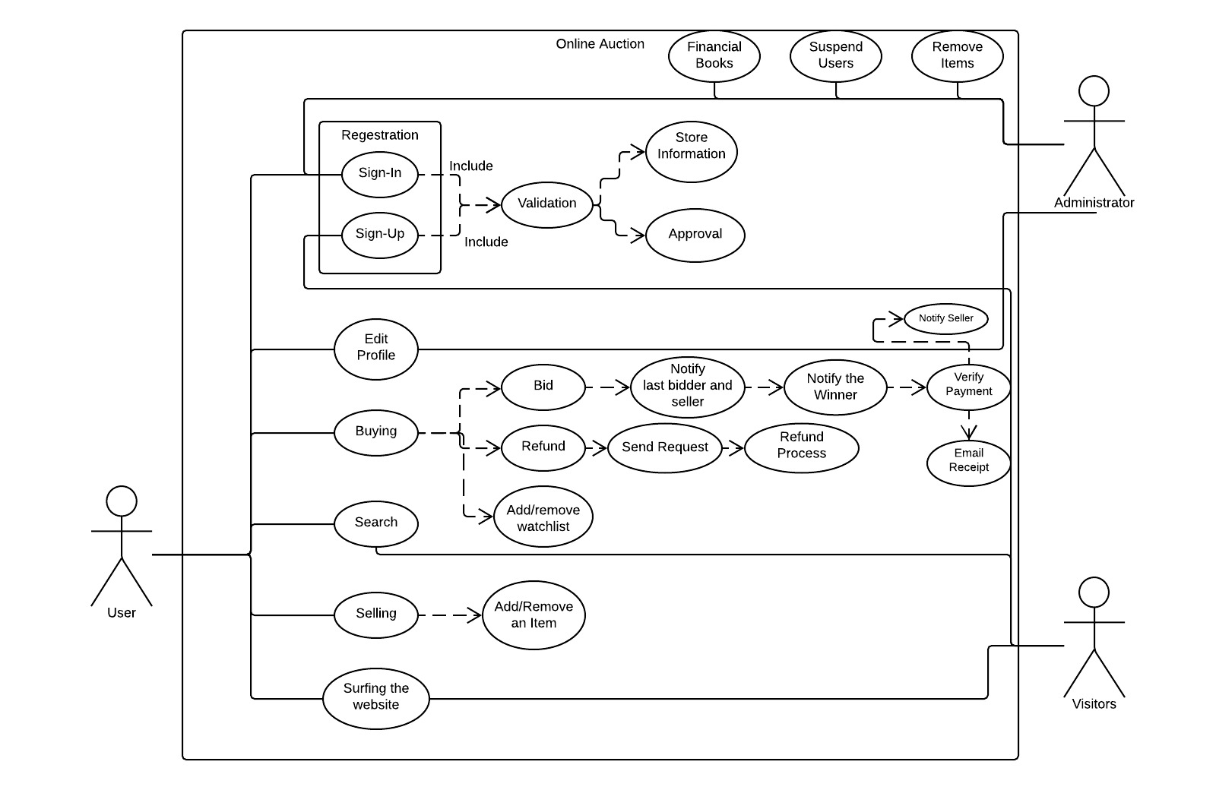

**Activity diagram:**

Buying

Administrator

Search

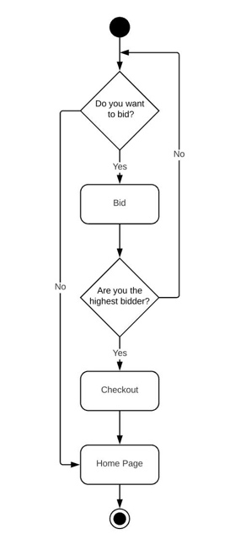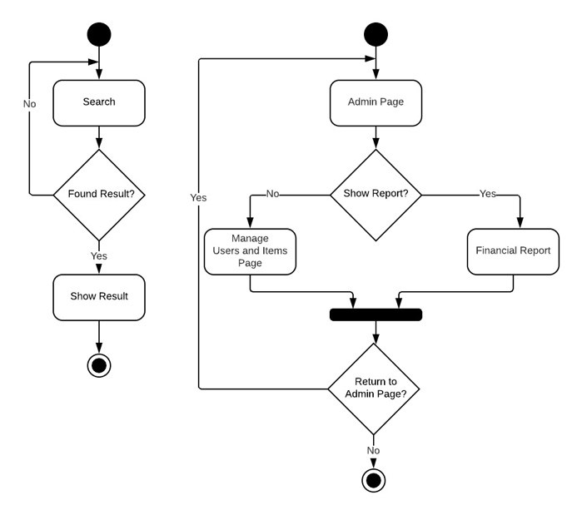

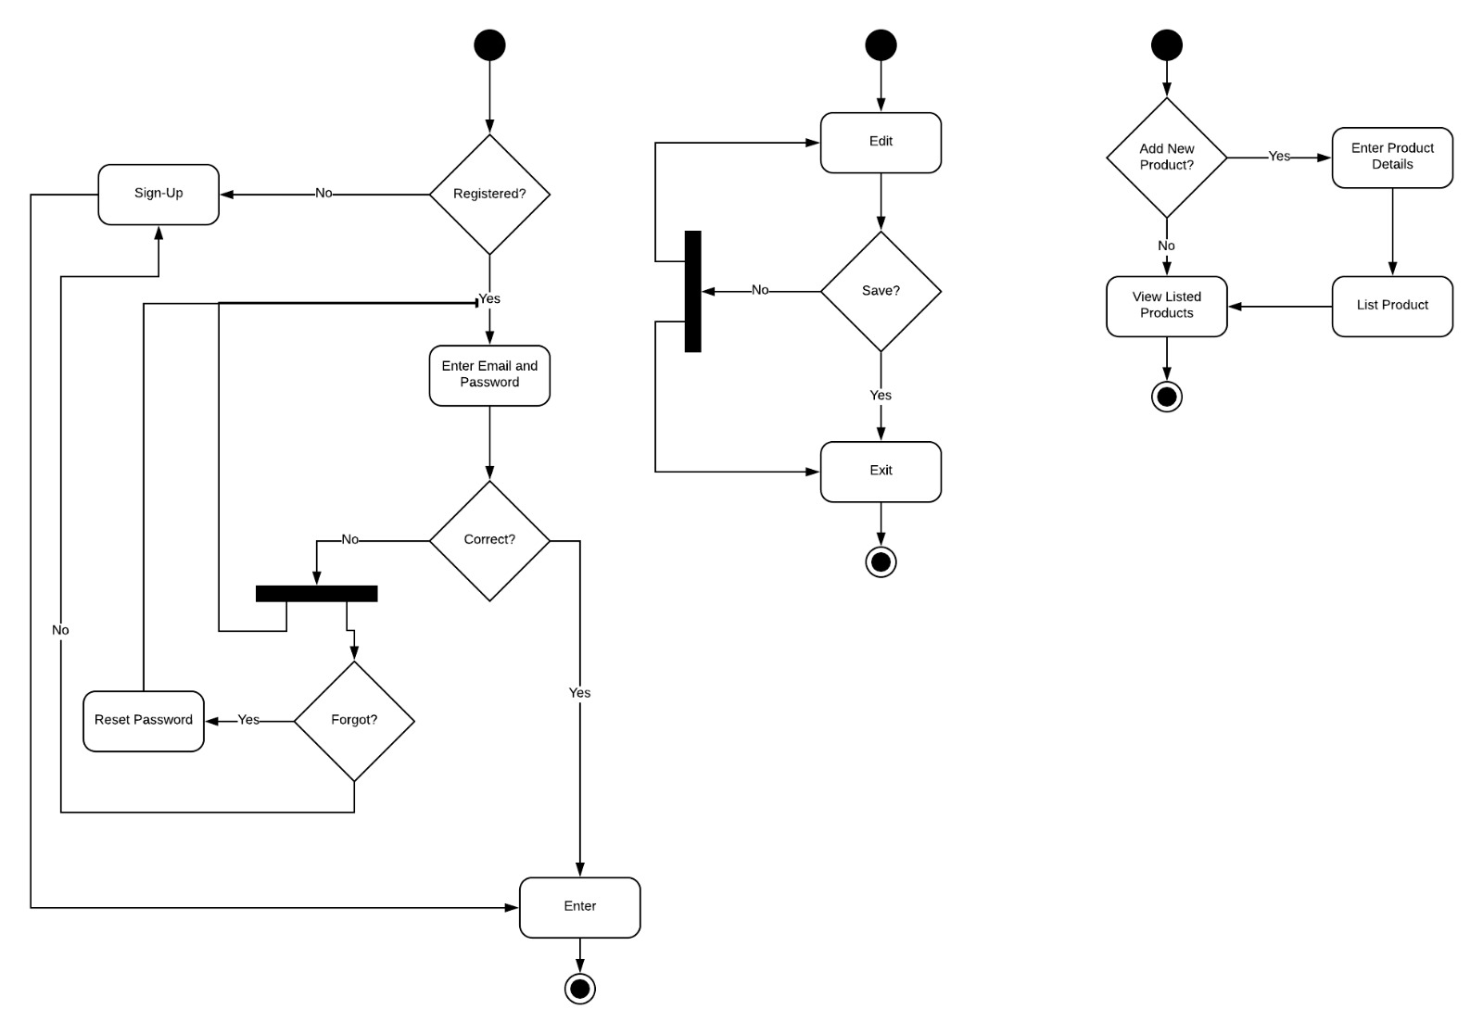

selling

Edit Information

Registration

**Structural modeling:**

**Class diagram**

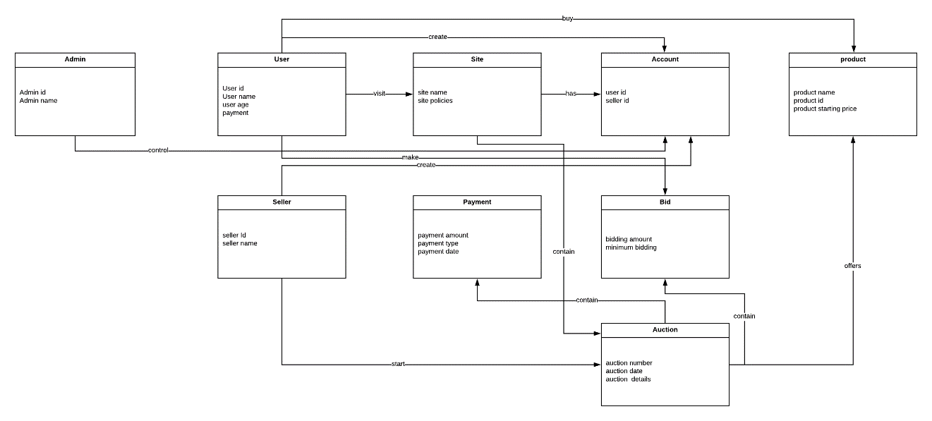

**Behavioral modeling:**

**Sequence diagram:**

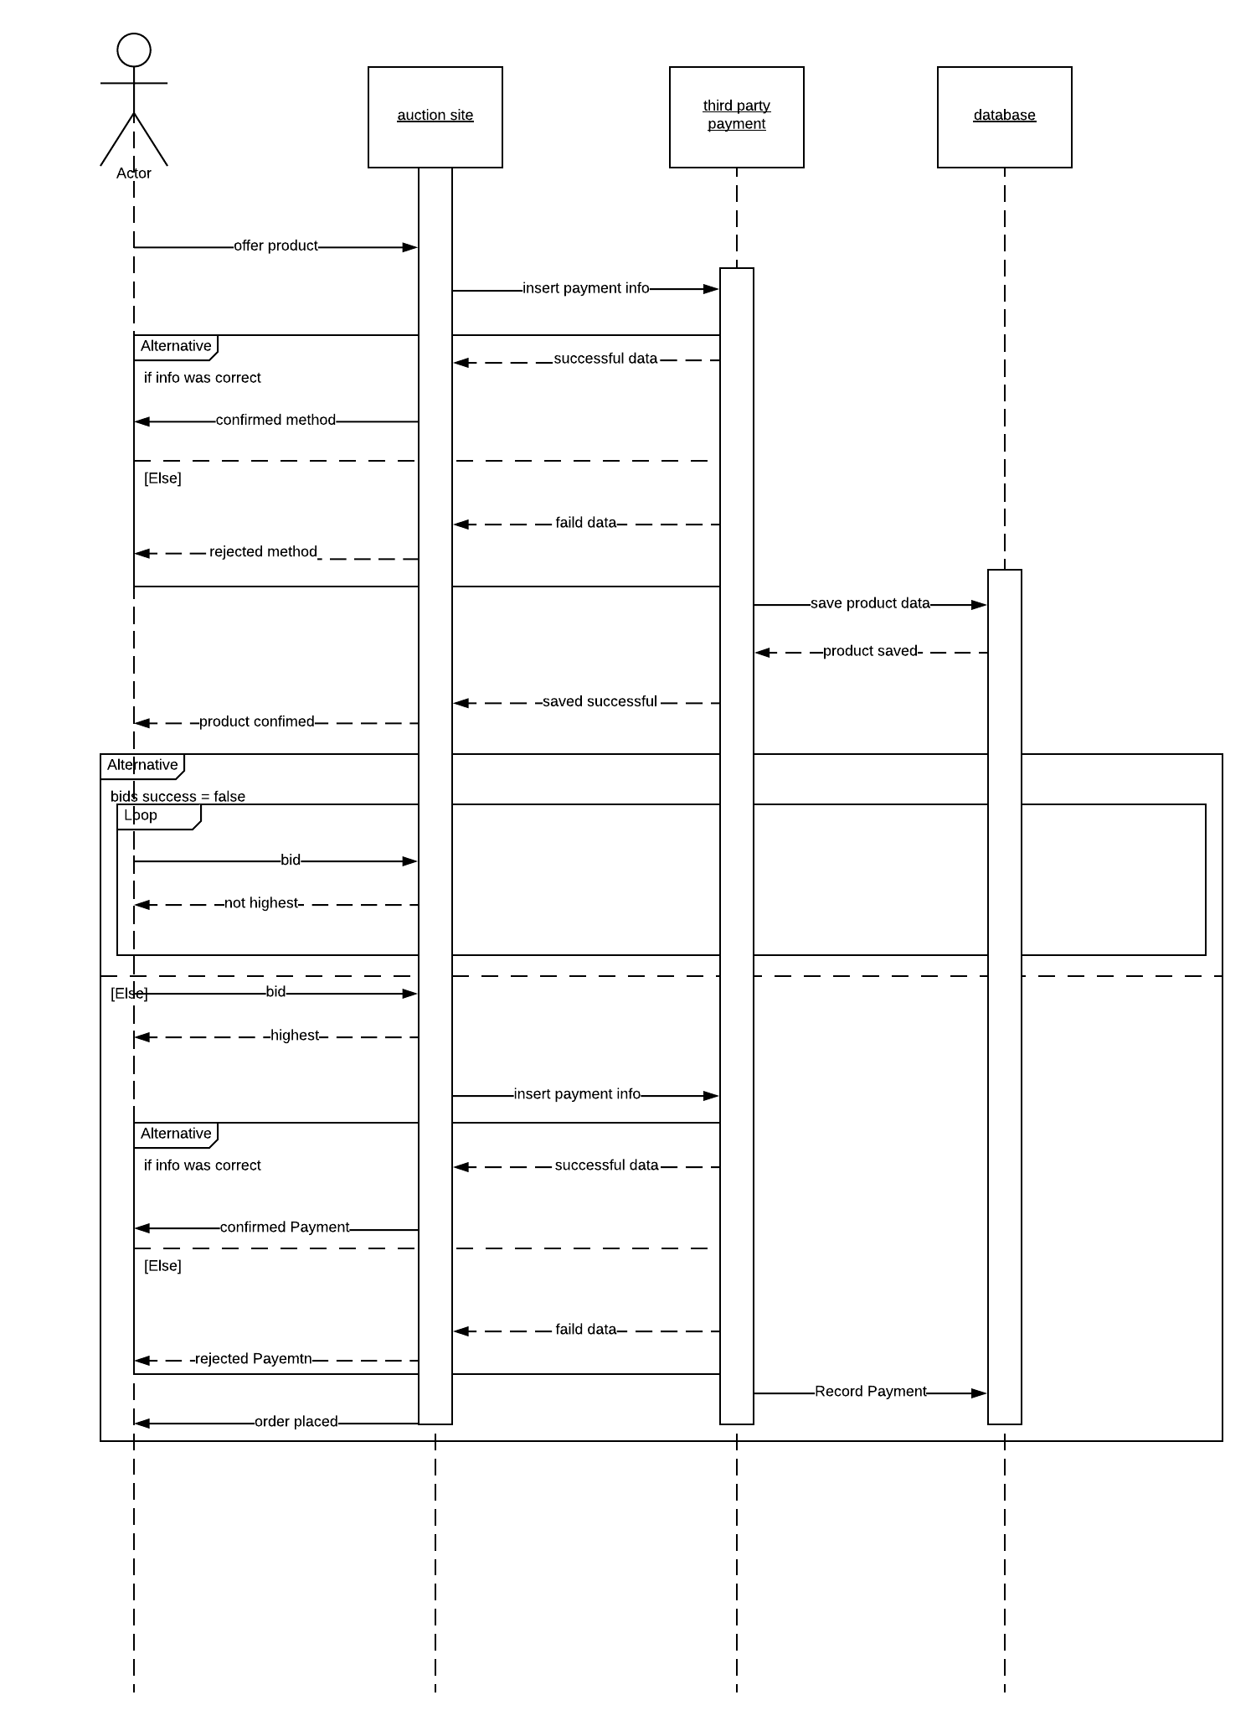

**Communication diagram:**

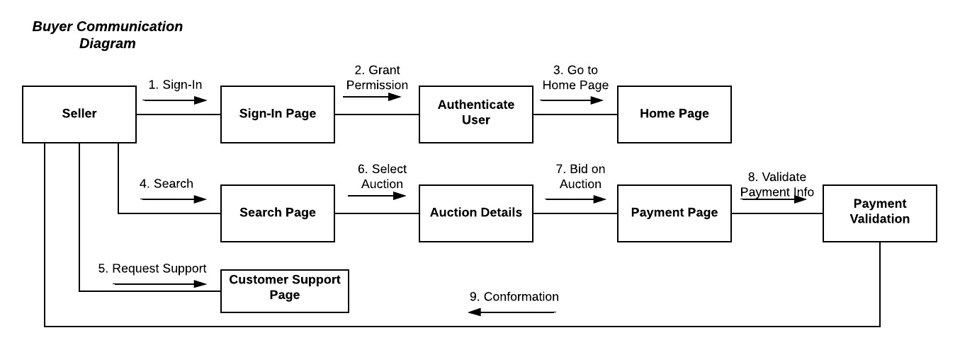

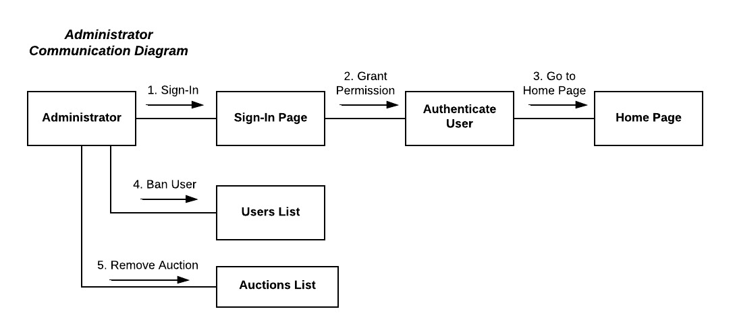

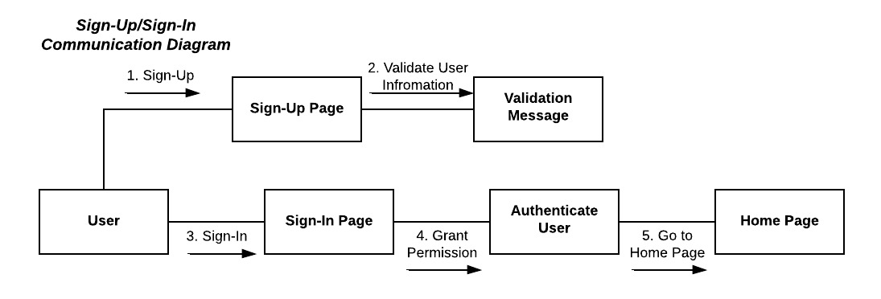

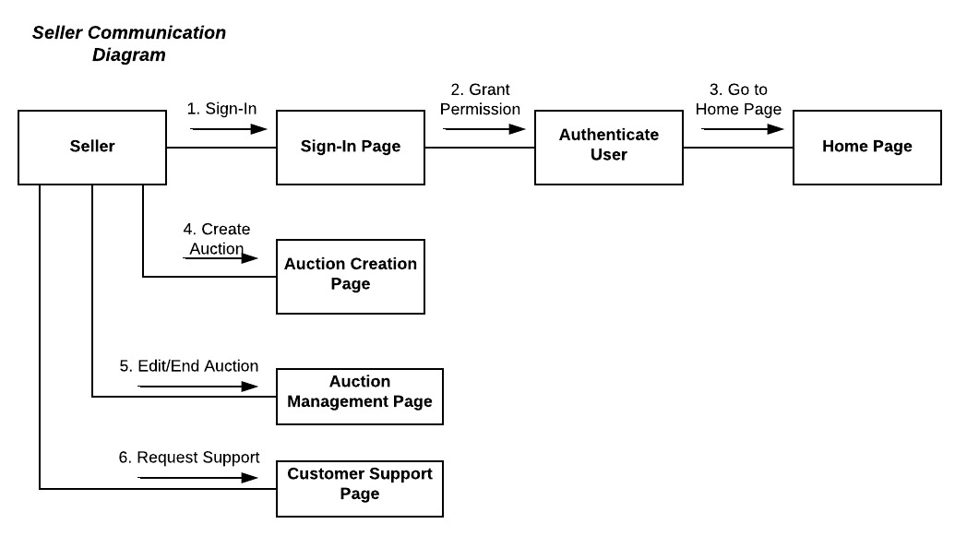

**State machine diagram:**

